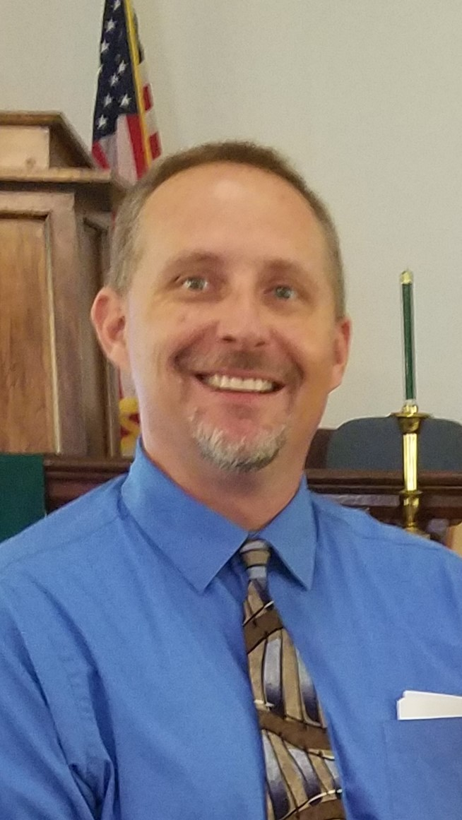
I was born in Northwest Indiana, spent some childhood years in Tomball, TX, and then moved to San Diego, CA. My family and I moved to Driftwood in 2008 and come to you by way of Wimberley UMC. I am currently a part-time student at Austin Presbyterian Theological Seminary. I am a second-career pastor, spending all of my previous career in the hospitality/restaurant industry. My career has been about service to others, about being in relationship with many different people with many different backgrounds, and about leading people to a common goal. Bringing different views and different people together by understanding each other, respecting each other, and loving each other is, I believe, a key to growing a church.
My wife Sandy and I have been together for over 16 years. She currently is a high school teacher at Lake Travis HS, teaching government. We are blessed with two growing young sons. Jacob is 16 and Ethan is 15. I enjoy spending time with my family, golfing, fishing, reading, and listening to music. When I want to get away and refresh myself I like to jump on the John Deere and mow the grass.
My passion for ministry stems from my two children. I want them to grow up knowing the grace and peace of Jesus in their lives and how his words and actions are guide posts to how we should live. This led me to a desire to spread this message to those around me. My passions in ministry are music (though I cannot sing nor play an instrument), serving the local community, and hearing an inspirational sermon. I believe the Gospel is the perfect guidebook on how to treat others and how to be a disciple of Christ. I also believe that the best way to be the hands and feet of Christ is to be actively involved in our communities. To me this means not only attending events or responding to the needs of the community, but also being a living example of Christ in our everyday interactions with each other and with those we come in contact with outside of the church. Being a disciple doesn’t come with an on/off switch.
I am incredibly excited and humbled to be able to join the Manor community and more specifically this church. I know that God has called me to this place at this time to help us impact the lives of those around us, and I feel very blessed to be part of it.

